**Database Assignment 2**

Name:-Rupali Barnwal

Roll:- 1705163

1. Write a SQL query to know the winner of the 1971 prize for Literature.

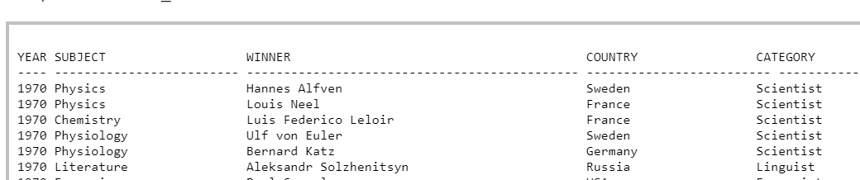

Ans: >select WINNER from table_name where YEAR=1971 and SUBJECT=”Literature”;

1. For the above data write a SQL query to give the name of the 'Physics' winners since the year 1950.

Ans: >select winner from table_name where year>=1950 and subject=”Physics”;

* Write a SQL query to Show all the details (year, subject, winner, country ) of the Chemistry prize winners between the year 1965 to 1975 inclusive.

Ans: >select year,subject,winner,country from table_name where subject=”Chemistry” and year between 1965 and 1975;

* Write a SQL query to show all details of the Prime Ministerial winners after 1972 of Menachem Begin and Yitzhak Rabin.(NOTE : Use ‘in’ clause)

Ans: >SELECT * FROM table_name WHERE year >1972 AND winner IN ('Menachem Begin','Yitzhak Rabin');

* Write a SQL query to show all the winners of nobel prize in the year 1970 except the subject Physiology and Economics(NOTE: Can use ‘not in’).

Ans: >select *from table_name WHERE year=1970 and subject NOT IN('Physiology','Economics');

* Write a SQL query to show the winners of a 'Physiology' prize in an early year before 1971 together with winners of a 'Peace' prize in a later year on and after the 1974.(NOTE : can use ‘union’)

Ans: >SELECT * FROM table_name WHERE (subject ='Physiology' AND year<1971) UNION (SELECT * FROM table_name WHERE (subject ='Peace' AND year>=1974));

1. Write a SQL query to find all the products with a price between Rs.200 and Rs.600.

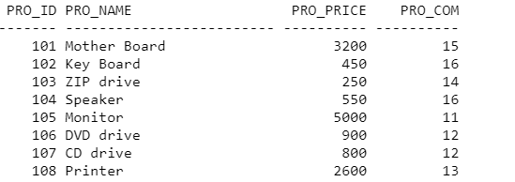

Ans: >select *from products where PRO_PRICE between 200 and 600;

* Write a SQL query to calculate the average price of all products of the manufacturer which code is 16.

Ans: >select AVG(PRO_PRICE) from products where PRO_COM=16;

* Write a SQL query to find the pro_name as item name and pro_price as price in Rs.

Ans: >select pro_name as item_name,pro_price as price from products;

* Write a SQL query to display the name and price of all the items with a price is equal or more than Rs.250, and order it by price in descending order.

Ans: > select pro_name,pro_price from products where pro_price>=250 order by pro_price desc;

* Write a SQL query to find the name and price of the cheapest item(s).

Ans: >SELECT pro_name, pro_price FROM products WHERE pro_price = (SELECT MIN(pro_price) FROM products);

1. Write a query in SQL to find the last name of all employees, without duplicates.

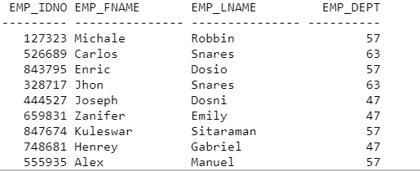

Ans: >select DISTINCT EMP_LNAME from employees;

* Write a query in SQL to display all the data of employees that work in the department 57.

Ans: >select *from employees where EMP_DEPT=57;

1. Consider the following relation:

Emp(ename,company_name,salary,job,depno)

Write the following sql queries:

* Display the salary by increasing the salary column by 3000

Ans: >update Emp set salary=(salary+3000);

>select salary from Emp;

* Find the company name whose salary is lowest salary

Ans: >select company_name from Emp where salary=(select MIN(salary) from Emp);

* Find the total salary where company name is TCS.

Ans: > select SUM(salary) as total_salary from Emp where company_name=”TCS”;